*International Journal of Disaster Risk Science*

Supporting Information for

**Significant Association Between Arctic Oscillation and Winter Wildfires in Southern China**

**Contents of this file**

Figures S1

**Introduction**

Figure S1a shows the February–March atmospheric circulations climatology in south China, Figure S1b displays the February–March 700 hPa horizontal wind in association with the simultaneous AO index from 2001 to 2022.

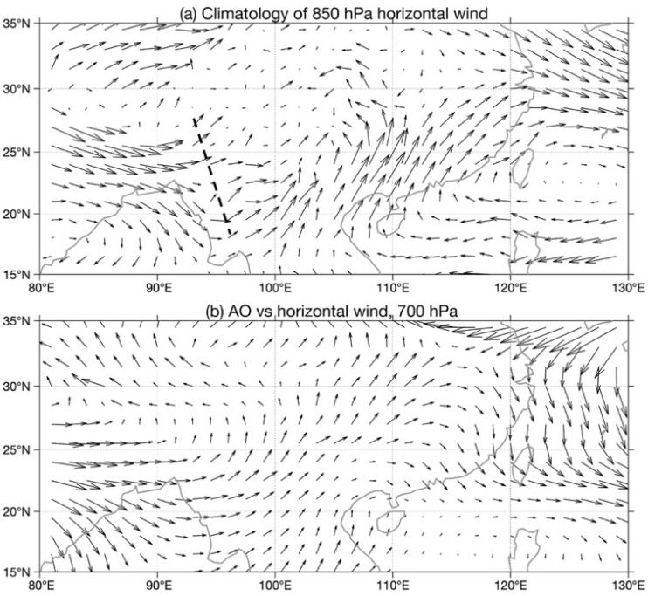

**Figure S1.** (a) Climatology of 850 hPa horizontal wind in February–March, (b) the February–March 700 hPa horizontal wind in association with the simultaneous AO index. Time period is from 2001 to 2022.